Network Topologies
Topology 1:
1. Created a network topology with a Layer 2 switch and two hosts connected. Each host is assigned an IP address, and this is a Class A network.
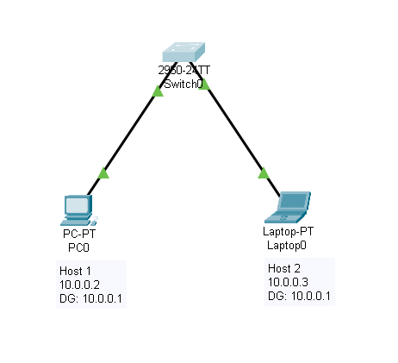
2 . Checked the IP address of Host1 (PC0) using the command `ipconfig`.
3. Checked the ARP cache for the MAC addresses of the hosts in this network.
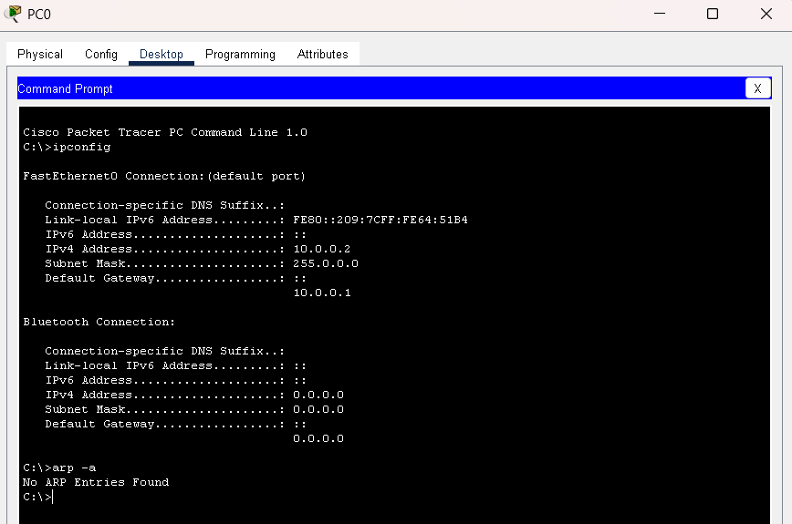
4. Initially, there are no entries in the ARP cache because no communication has occurred yet, so an ARP broadcast will be needed.
5. Before the ARP broadcast, the switch MAC address table is empty. This can be verified using the command `show mac address-table dynamic`.
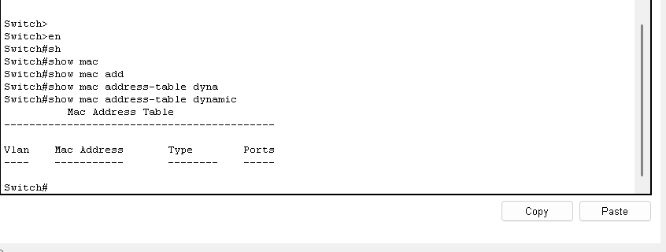

6. After the ARP broadcast, the switch MAC address table and the device ARP cache are updated.
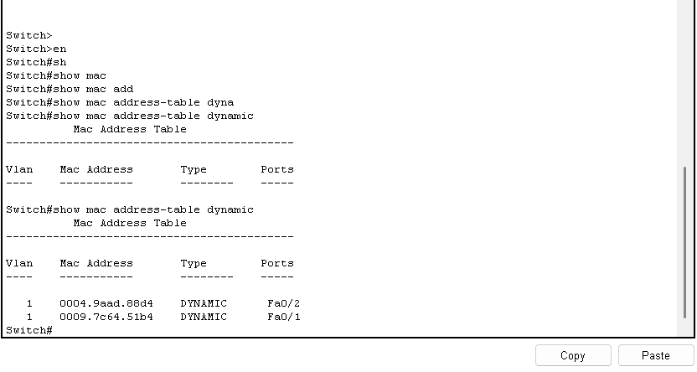
Switch mac-address Table
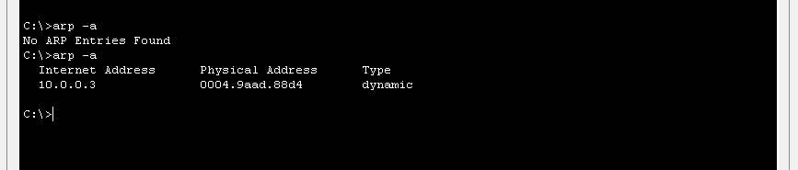
ARP cache in Host

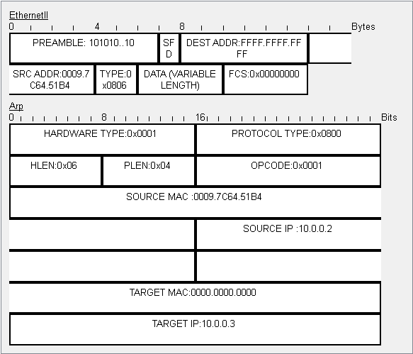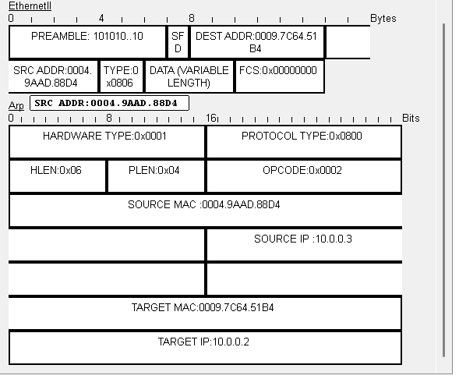
Before ARP Broadcast After ARP Broadcast
- When the host does not find the MAC address in its ARP cache, it sends an ARP Request, which the switch forwards as a broadcast.
- Before broadcasting, the host’s MAC address will not be present in the ARP protocol header as the destination. In the Ethernet II frame, the destination MAC will be FFFF:FFFF:FFFF, and in the ARP header, the Target MAC will be 0000:0000:0000. Once the ARP Reply is received after broadcasting, the destination MAC address will be known.
- After broadcasting, we can see that Host2 sends the ARP Reply to Host1. The ARP Reply contains the source IP as 10.0.0.3 and the target IP as 10.0.0.2.
- In this ARP Reply, the source MAC address belongs to Host2, and the reply is sent to the target Host1, whose IP address is 10.0.0.2 the one that initiated the ARP broadcast.
- When we try to ping from 10.0.0.2 to 10.0.0.3, this ARP exchange updates the ARP cache of both hosts as well as the MAC address table of the switch.
- After this, the hosts will directly communicate using unicast with the help of the MAC address table and ARP cache.

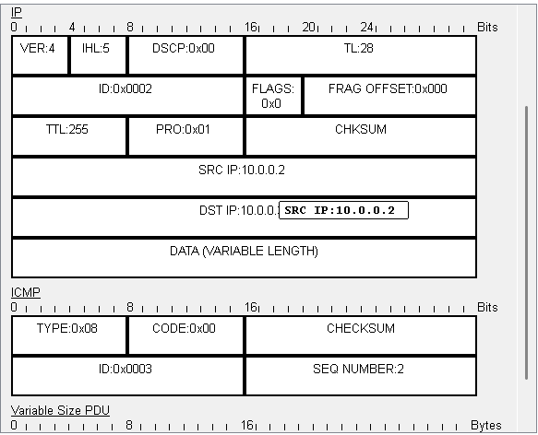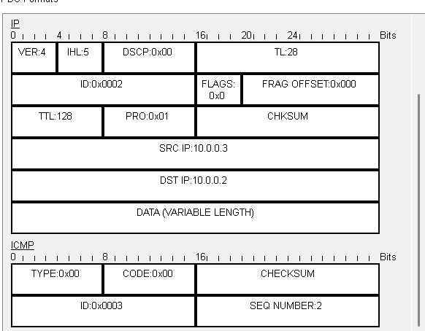
ICMP Request ICMP Response
- ICMP is a protocol used to diagnose network issues and check for errors before sending data.
- Ping and tracert are the utilities that use ICMP to achieve this.
- When we ping a destination, the ICMP message type is 0x08 (Echo Request), and the ICMP packet is sent to the destination.
- The response from the destination is an Echo Reply with type 0x00 and the same code as the Echo Request.
- If there is no error, we receive the Echo Reply. If there is an issue, we may get error messages such as Destination Host Unreachable or Destination Port Unreachable.
- Each ICMP error message has a specific type—for example, type 0x03 is Destination Unreachable, and type 0x11 is Time to Live Exceeded.
- There are many such ICMP error messages, each identified by a different type value.

Network Topology – 02:
This topology demonstrates communication between two different networks using a single router. Each network has its own Layer 2 switch, and the router (a Layer 3 device) enables communication between these networks by serving as their default gateway.
• Fig 2.1 shows the topology with two networks: 10.0.0.0 and 11.0.0.0.
• Each network has its own switch and hosts.
• The router connects both networks and provides gateway IP addresses for communication.
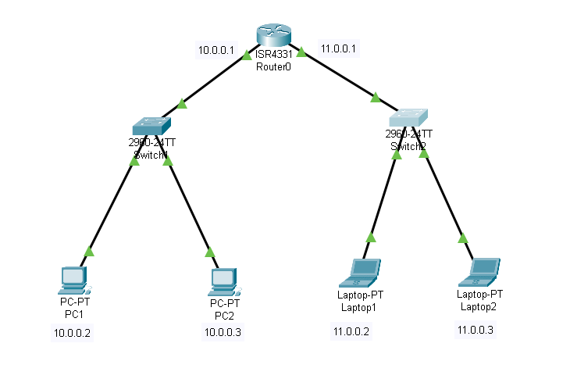
Fig: 2.1
• The default gateway for each host is the first usable IP address in the subnet.
• In the 10.0.0.0 network, the gateway is 10.0.0.1. The host details can be verified using the `ipconfig` command (Fig 2.2).
• Initially, the ARP cache remains empty since no communication has yet occurred.
• Similarly, in the 11.0.0.0 network, the default gateway is 11.0.0.1 (Fig 2.3), and again the ARP cache is empty.

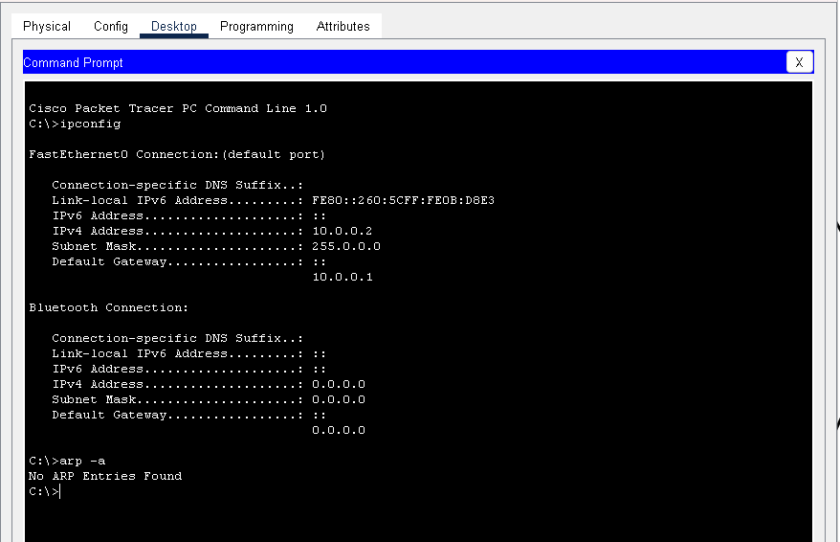
Fig: 2.2 – IP Address of Host
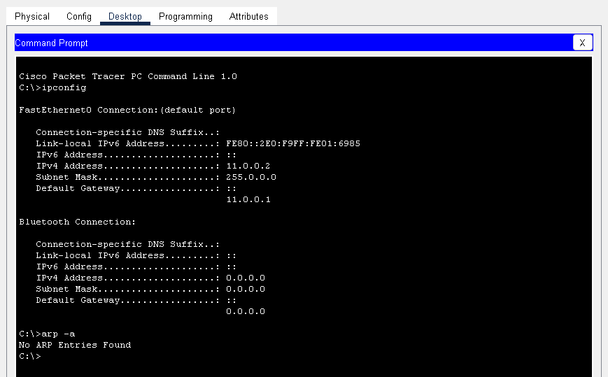
Fig: 2.3
The two Layer 2 switches initially have empty MAC address tables.
• This can be confirmed with the command `show mac address-table dynamic`.
• Fig 2.4 shows Switch1’s MAC address table (empty).
• Fig 2.5 shows Switch2’s MAC address table (empty).

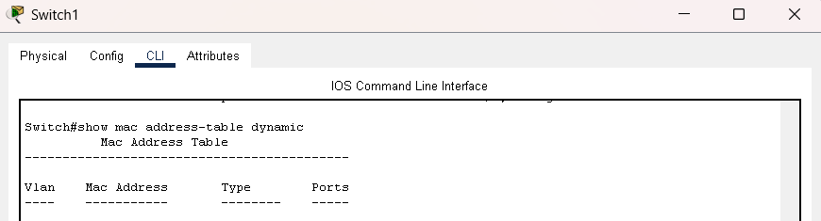
Fig: 2.4 – Switch1 MAC Address table
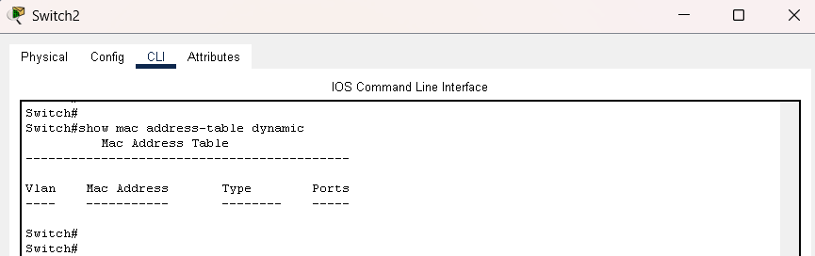
Fig: 2.5 – Switch2 MAC address table
- A single router is sufficient for communication between the two networks.
• The router’s routing table lists the connected networks (Fig 2.6).

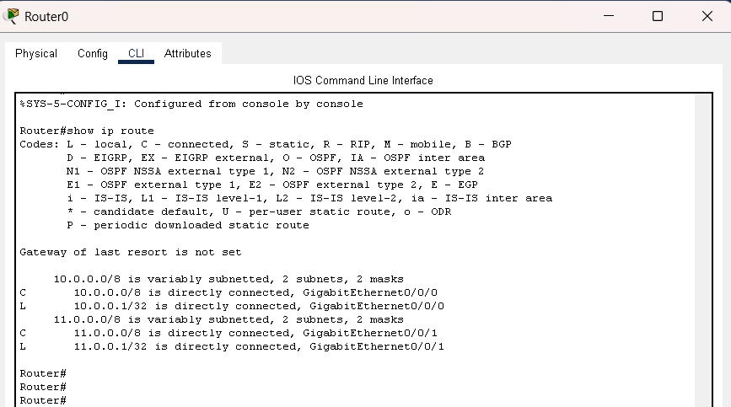
Fig: 2.6 – Routing table of Router 0
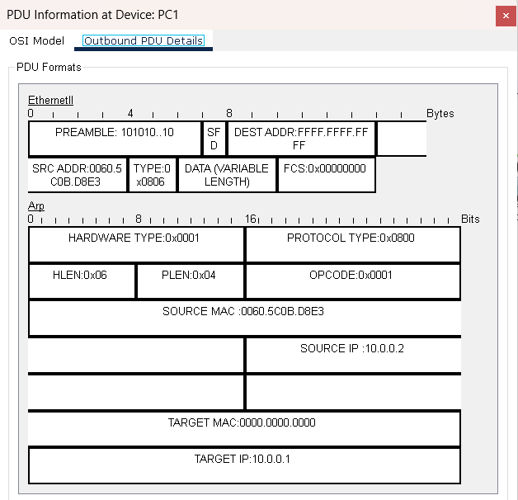
Fig: 2.7 – ARP Broadcast by Host 10.0.0.2
When Host 10.0.0.2 initiates communication, it checks its ARP cache. Since the destination MAC is unknown, it sends an ARP broadcast (Fig 2.7).
• If the switch does not yet know the MAC address, it forwards the broadcast to all devices.
• In Fig 2.8, the ARP request is received by 10.0.0.3, which is not the intended target, so the packet is dropped. However, the switch learns the MAC address.
• The router then helps the source reach the destination in the other network.
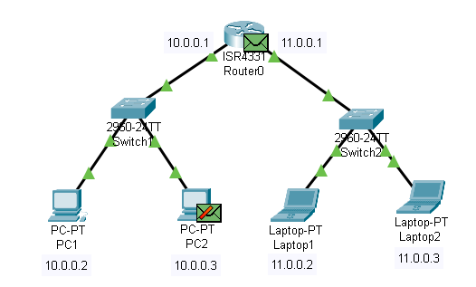
Fig: 2.8 -Packet drop by PC 2
- The ICMP packet is sent to the router (the default gateway). Since the router does not yet know the MAC address of the remote destination, it also sends an ARP request to the 11.0.0.0 network (Fig 2.9 and Fig 2.10).
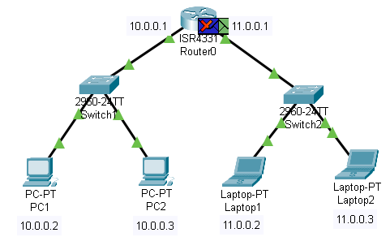
Fig: 2.9 – ICMP packet drop
• Fig 2.12 shows the ARP reply from the correct host (11.0.0.3). Now the router has the MAC address mapping.
- In Fig .2.9 we can see the ICMP packet drop because it reached the default gateway but the router don’t have the destination mac address so again the ARP broadcast to the 11.0.0.0 network will be done
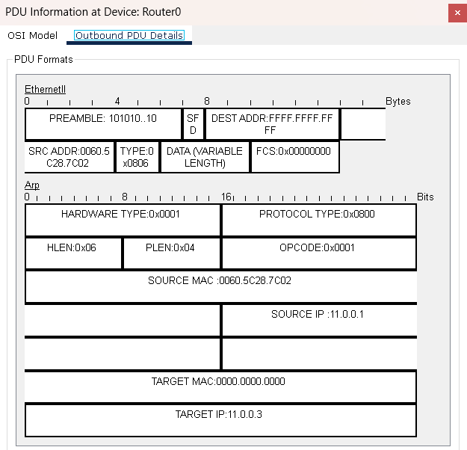
Fig: 2.10-ARP request to 11.0.0.0
- Here in Fig: 2.10 we can see the source is that router’s default gateway of 11.0.0.0 network and the destination is same that is 11.0.0.3 because the 10.0.0.2 is looking for 11.0.0.3
- In Fig 2.11, the ARP request is seen at another host which drops it because it is not the target.
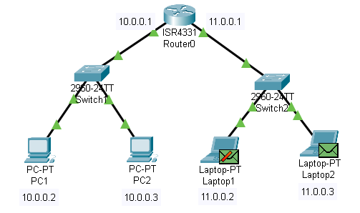
Fig: 2.11 – Packet drop at 11.0.0.2
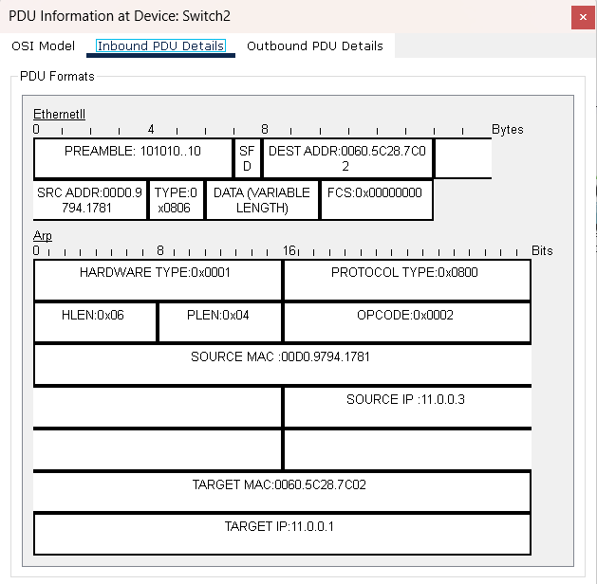
Fig: 2.12 – The ARP response from 11.0.0.3
- Fig 2.12 shows the ARP reply from the correct host (11.0.0.3). Now the router has the MAC address mapping.
- With the MAC address resolved, the ICMP request is sent successfully to the destination host (Fig 2.13).
- The source and destination IP addresses remain unchanged end-to-end, but the MAC addresses change hop by hop.
- The reply from the destination is an ICMP Echo Reply (Fig 2.14).
- Finally, Fig 2.15 confirms that the ICMP request succeeded.
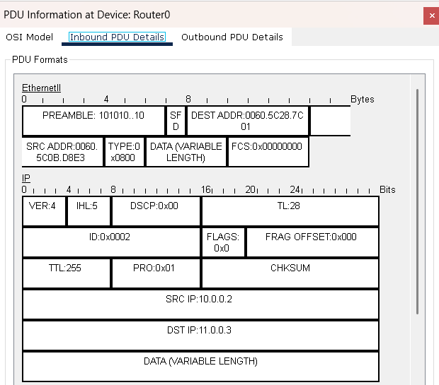
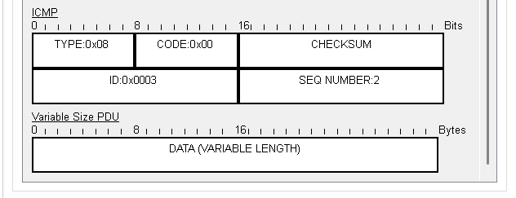
Fig: 2.13 – ICMP request details

- These are the details of ICMP request and In Fig. 2.14 we can see the details of the ICMP response or echo response

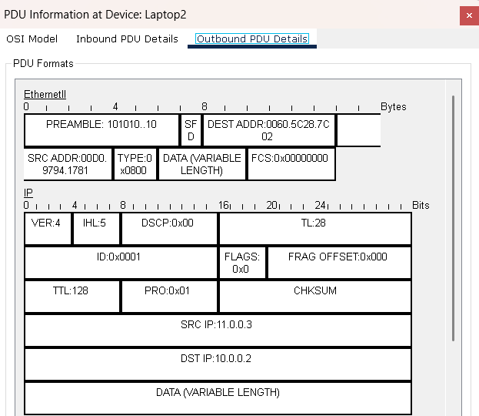
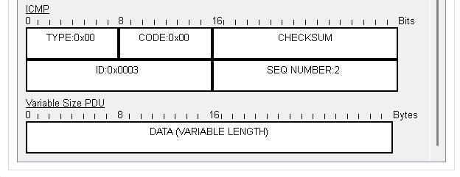
Fig: 2.14 – ICMP response
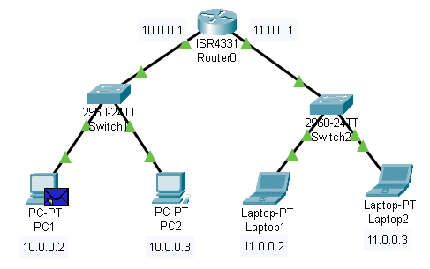
Fig: 2.15 The ICMP request is Succeeded

- This process illustrates how two networks communicate for the first time
- Initially, ARP caches and MAC address tables are empty.
- ARP broadcasts and replies populate the required tables.
- Once MAC addresses are known, ICMP communication succeeds.
- Subsequent communication occurs directly without repeated broadcasts.

Network Topology – 03
This topology is the communication between two different networks using two routers. Each network has its own Layer 2 switch. The routers Layer 3 devices enable communication between the networks, and static routing is configured between the routers to allow end-to-end communication and reachability.
- Fig 3.1 shows the overall topology with two networks, each connected to its own switch, and two routers in between to interconnect the networks.
- The routers provide gateway IP addresses for their directly connected networks.
- Static routes are configured so that traffic can reach the other network via the router
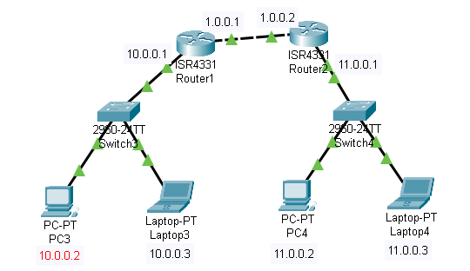
Fig: 3.1
- The default gateway for each host is the first usable IP address in its subnet.
- Host details like IP address and default gateway can be verified using the `ipconfig` command we can see it in Fig 3.2 and Fig 3.3 for both the networks.
- Initially, the ARP cache remains empty because no communication has been initiated yet.
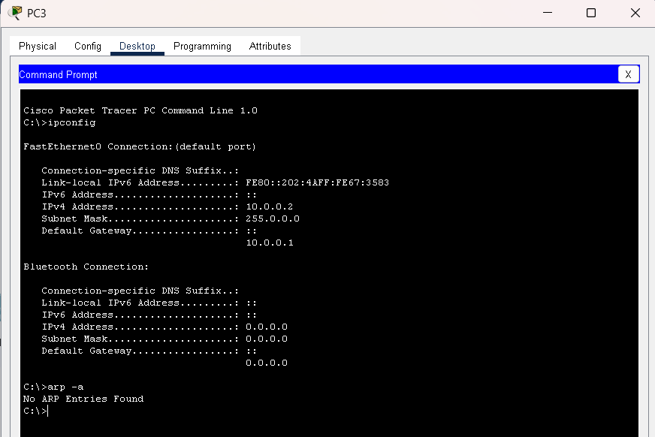
Fig: 3.2
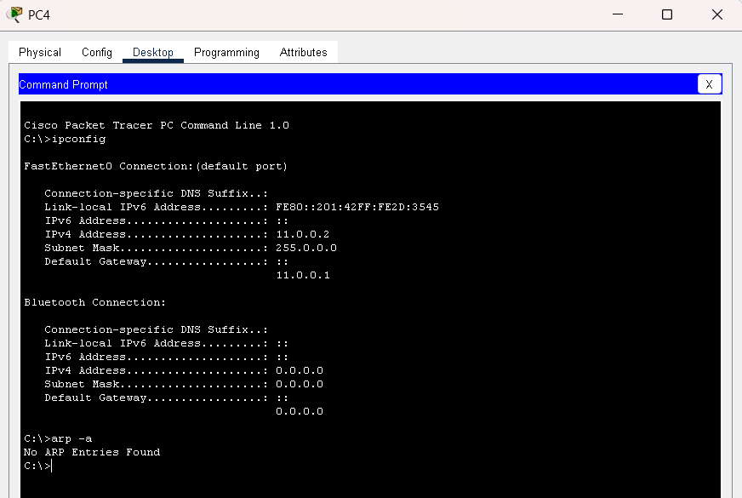
Fig: 3.3
- The hosts in the other network also use their subnet’s first IP as the default gateway.
- Their ARP cache is also empty before any communication occurs we can see this in Fig 3.3.
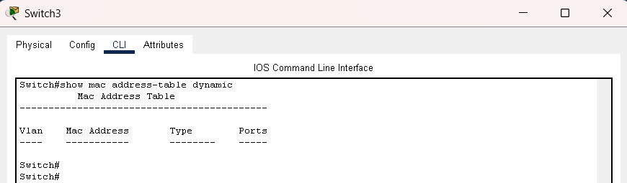
Fig: 3.4 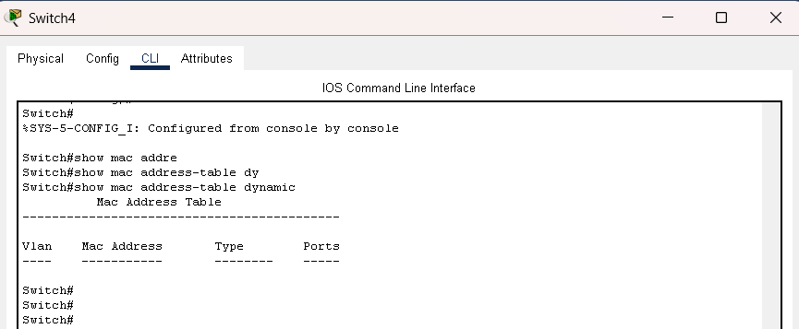
Fig: 3.5
• Both Layer 2 switches start with empty MAC address tables.
• This can be verified with the command `show mac address-table dynamic`.
• Fig 3.4 shows Switch1’s MAC address table.
• Fig 3.5 shows Switch2’s MAC address table.
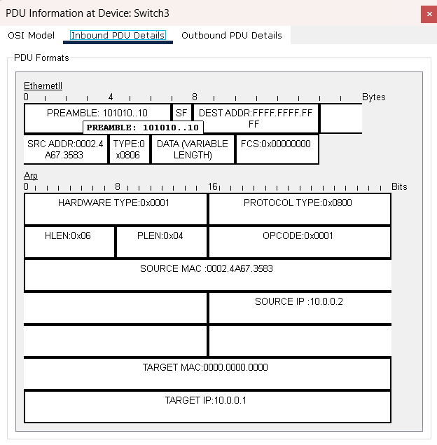
Fig: 3.5
- When a host initiates communication to a remote host, it first checks its ARP cache. Since the destination MAC is unknown, it sends an ARP broadcast see Fig 3.5.
- If a switch does not yet know a MAC address, it forwards the broadcast to all devices in the network. Non-target hosts drop the ARP request, but the switch learns their source MACs from this broadcast see Fig 3.6 and Fig 3.7
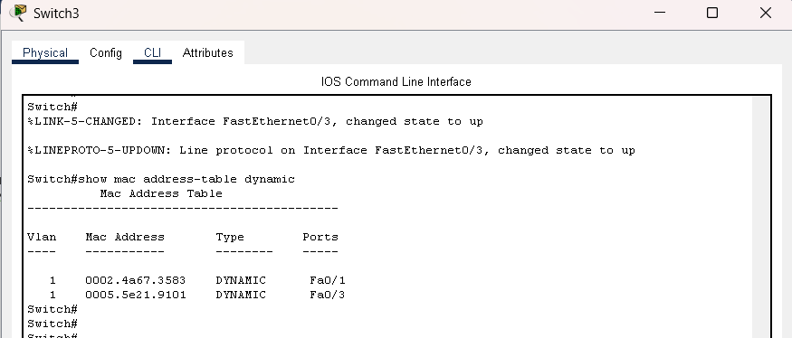
Fig: 3.6
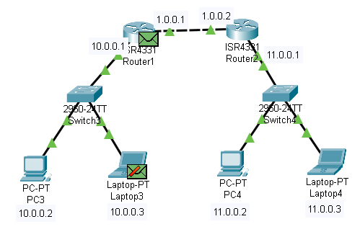
Fig: 3.7
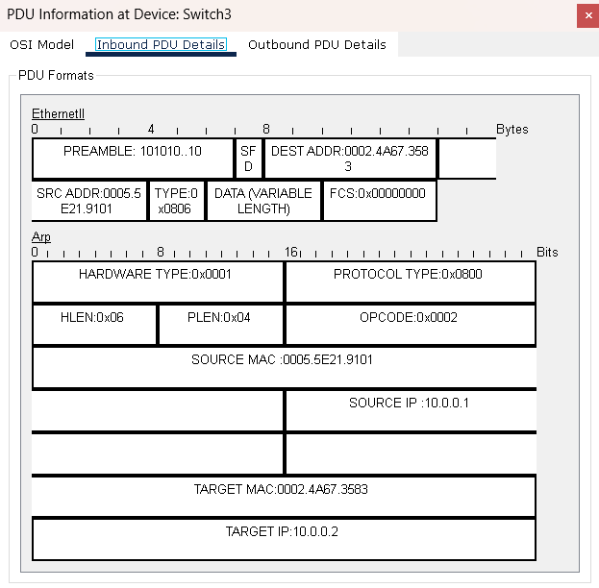
Fig: 3.8
- The ARP response from the router’s default gateway to the requested host.

- The host sends the ICMP packet to its default gateway the local router. If the router does not yet know the MAC address of the next hop toward the destination network, it performs an ARP request on its outgoing interface.
- ARP requests may be seen by multiple hosts on that segment. Non-target hosts drop the request.
- Since here we have 2 networks we have to configure the routing either it can be static routing or using the routing protocols.
- Till that the further communication won’t happen the packets will drop in that default gateway itself.
- We can see that in the Fig.3.9

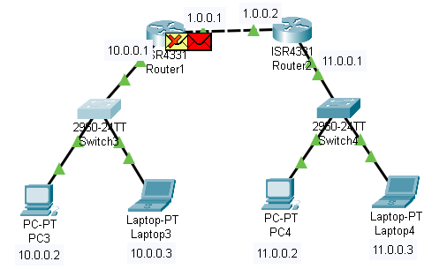
Fig: 3.9
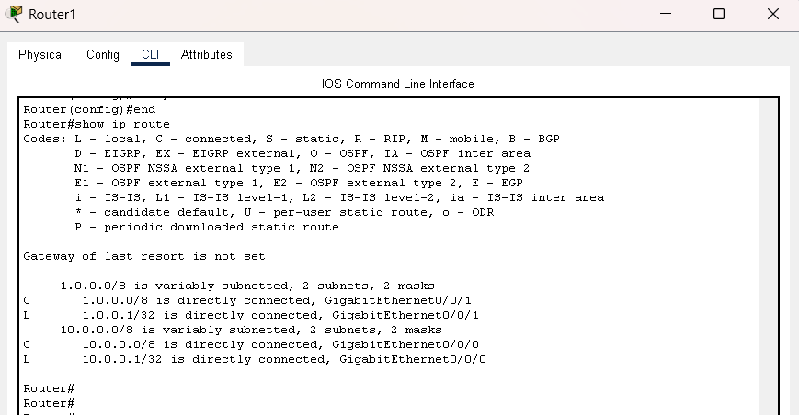
Fig: 3.10
- Fig: 3.10 is the routing table of the first router and we can see that there is no routing for the network 11.0.0.0 only the 10.0.0.0 and the 1.0.0.0 is connected so the router will not send packets further.

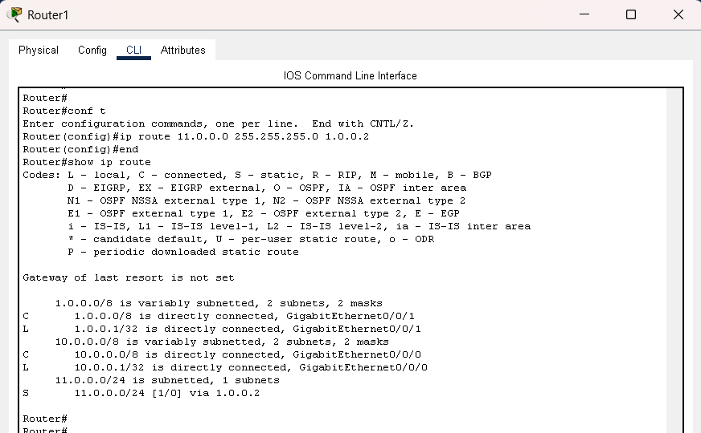
Fig: 3.11
- Now the static configuration is done and the routing for the destination network is available.
- In the Fig: 3.11 we can see that configuration is done and the command used is “ip route destination network subnet mask via” this is the syntax for configuring the static routing
- In our case it is ip route 11.0.0.0 255.0.0.0 1.0.0.2
- Now the ARP request will be sent to the 1.0.0.0 network to get the mac address of that router then the ICMP packet will be sent.
- The Fig: 3.12 shows the ICMP packet details.
- The ICMP packet will be dropped at the next hop because it don’t know the mac address of the destination
- The ARP request will happen and then the ICMP packet will be sent.
- In the Fig:3.12 and 3.13 we can see this ICMP packet drop and the ARP request.
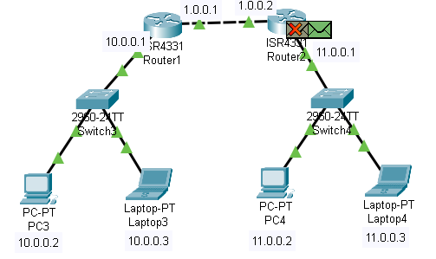
Fig: 3.12

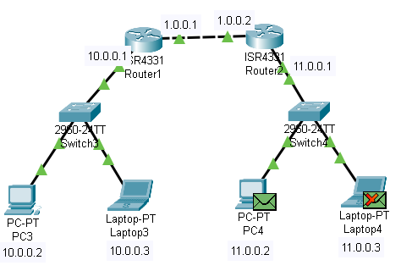
Fig: 3.13

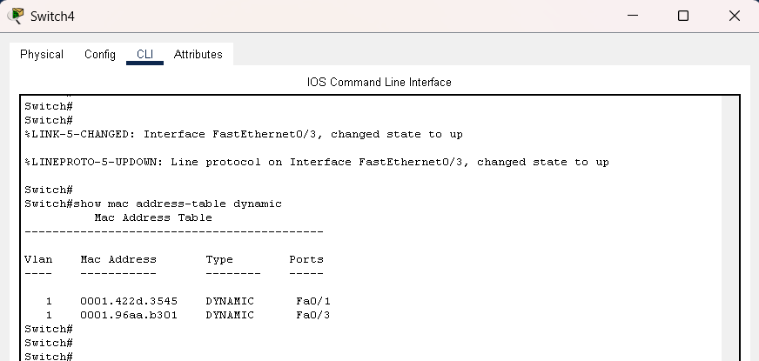
Fig: 3.14

- In the switch we can see that the table is updated because pf the ARP request by router
- Fig: 3.14 shows the updated table of the switch
- In Fig: 3.15 we can see that the ICMP type field we have 0x03 where it means the destination unreachable and it occurs before the static routing configuration.

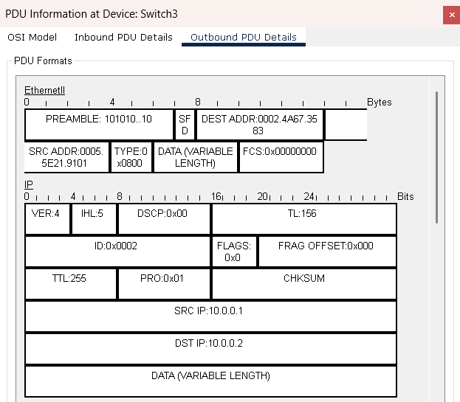
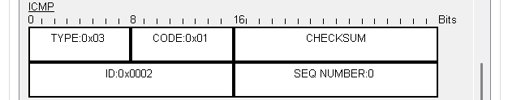
Fig: 3.15

- Also even though we did the static routing configuration we need in the first router the to reach 11.0.0.0 we haven’t done the routing configuration in the router 2 to reach the 10.0.0.0 network so we need to do.
- The figure 3.16 and 3.17 shows the routing configurations of the second router before doing the static routing configuration and the after the static router configuration.
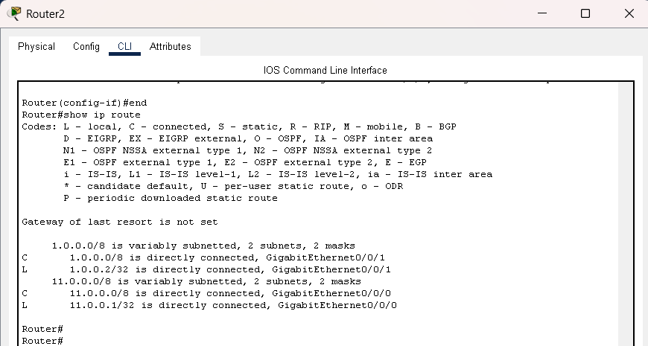
Fig: 3.16
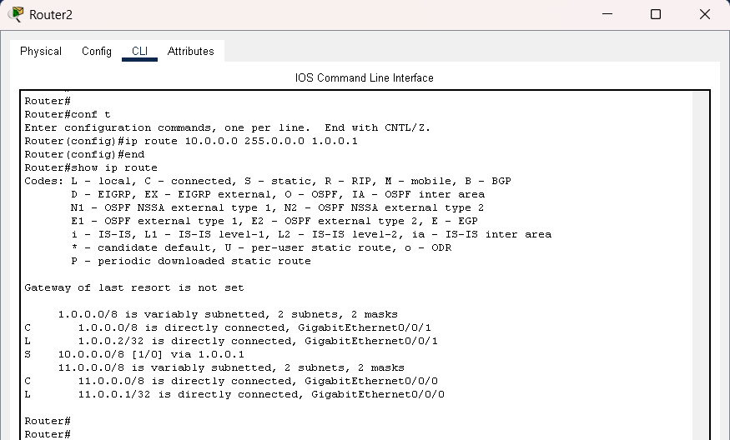
Fig: 3.17
- Now the successful communication will happen successfully because we have configured the static routing in both the routers.
- The TTL value will be decreased for each hop we can see that in the below figures

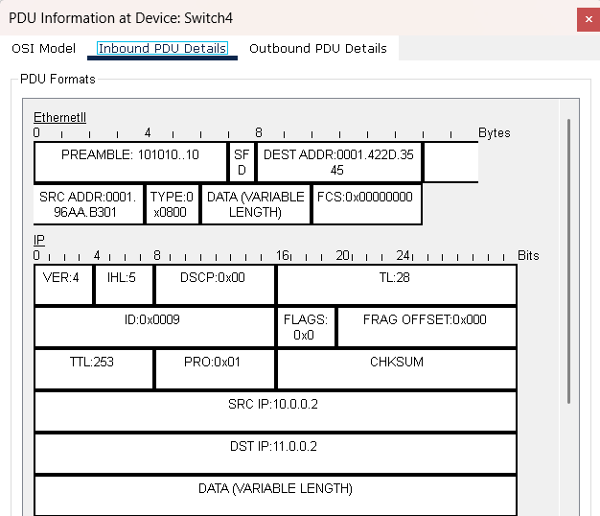
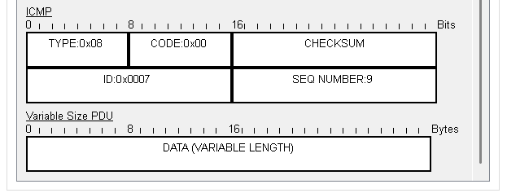
Fig: 3.18
- We can see that TTL is decreased to 253 because we have 2 routers so the TTL value is reduced by 2.

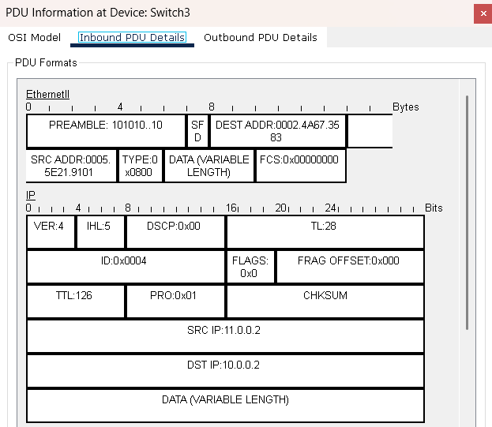
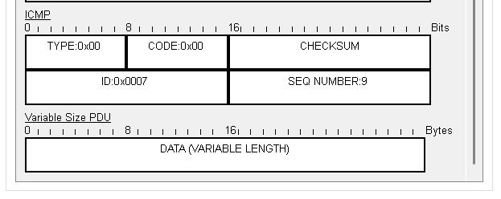
Fig: 3.19
- Here we can see the TTL value is decreased by 2 from 128 to 126 to respond to the source 10.0.0.2 as we know the ip packet will change it’s source and destination once it gets the response.

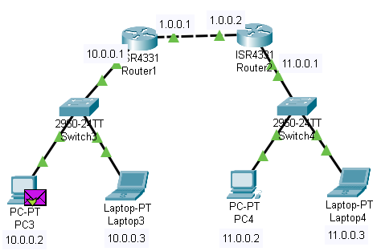
Fig: 3.20
- This is how we do static routing and the packet flow will happen between different hops.

Network Topology: Routing with RIP
- This is a same network topology as similar to the previous topology but instead of using static routing I used RIP
- RIP-Routing information protocol is used to find the best path for routing the best path based on the hop count.
- The maximum hop count is 15 and it will do it by changing the routing information between routers
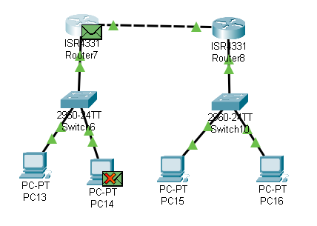
Fig:3.1.1- ARP request By Host
- IN Fig 3.11 we can see the host did the ARP request because it don’t the default gateway mac because the destination we are looking is in different network.
- In the below Fig:3.1.2 we can see the ARP response that is the default gateway mac to the source and now ICMP packet will send.
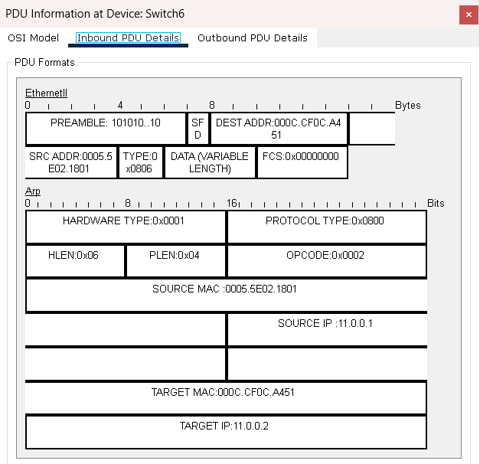
Fig: 3.1.3 - ARP Response from Router
In the Fig:3.1.4 we can see the ICMP packet details from source to destination.
Also we can it’s a echo request and the type is 0x08 and we can see the source and destination address .

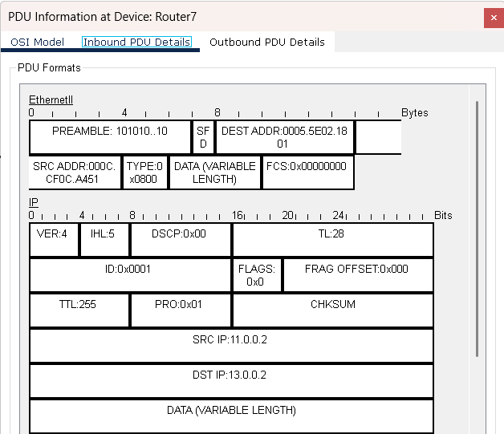
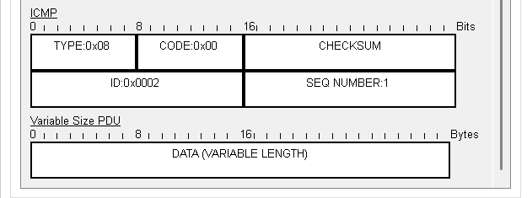
Fig: 3.1.4 – The ICMP echo Request

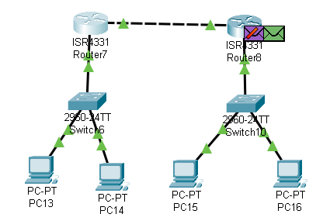
Fig: 3.1.5 – The ICMP Packet drop
- We can see that the packet is dropped at the second router in Fig: 3.15
- ICMP packet reachd that network directly because it learned it with the help of the routing protocol
- And in images we can see the R in routing table because it learned that route with the RIP.
- Then why it is dropped because it don’t knoe the mac address that’s why it is dropped.
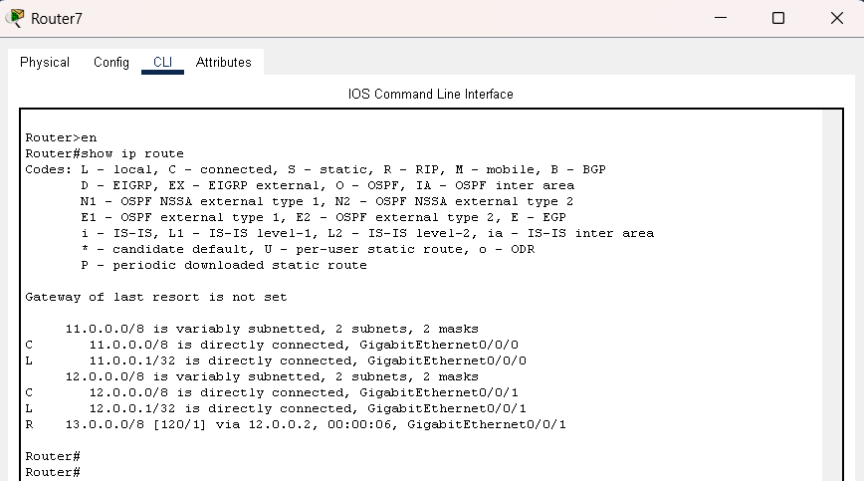
Fig:3.1.6 – Routes in the first router
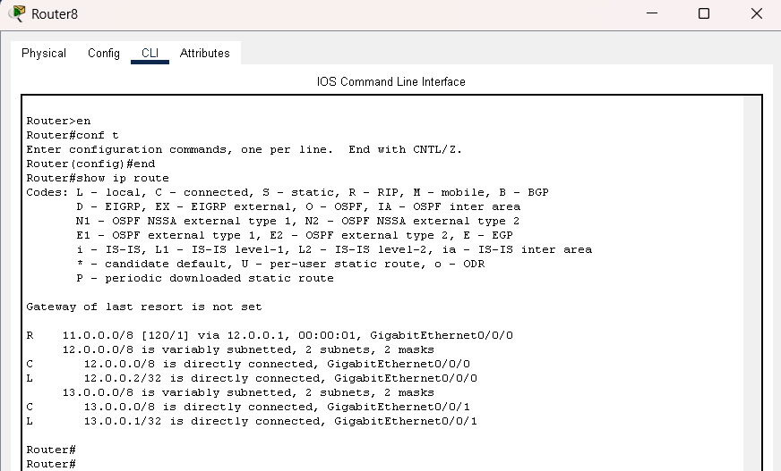
Fig:3.1.7 – Routes in the second router

- In the Fig:3.1.8 and 3.1.9 we can see the details of the ARP request from the second router and the source and destination is the source is the default gateway not the host.
- This is how this mac address will keep on changing from hop to hop till it reaches the destination and it will make it sure from the ip address.

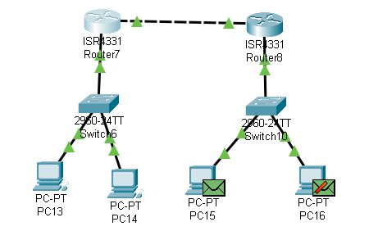
Fig:3.1.8

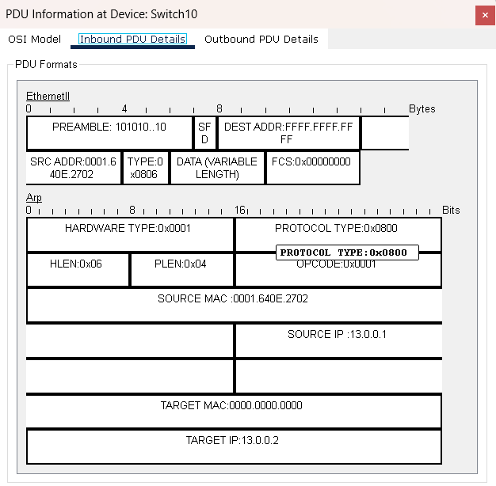
Fig:3.1.9

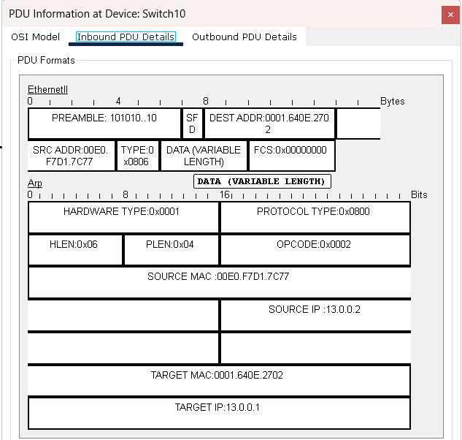
Fig: 3.1.10
- This is the response from the destination host and it is sending the mac address of it to that router and noe the communication can happen without any interruptions.
- In the Fig: 3.1.11 and 3.1.12 we can see the ICMP request and the ICMP response packet details and that is how the successfu communication can happen.
- And this RIP makes this flow better and it will automatically updates that routing table.
- The maximum hop count is 15
- It can be used for small networks where we have less than 15 hops we can go for this RIP else we can go for other routing protocols like OSPF.

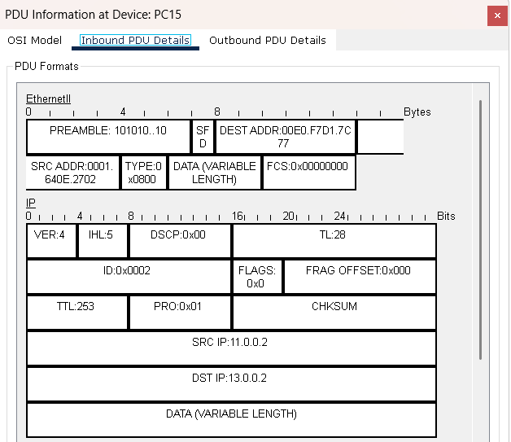
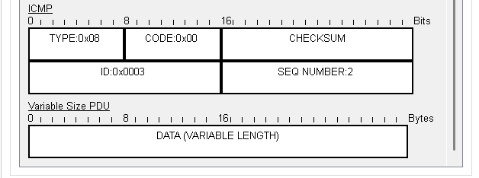
Fig:3.1.11

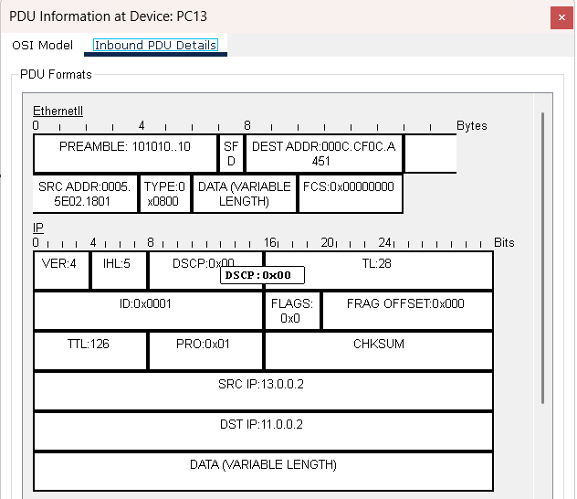
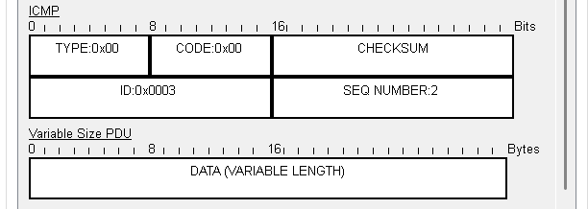
Fig:3.1.12
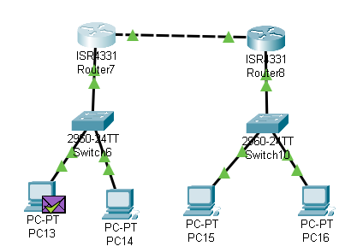
Fig:3.1.13
- Important commands to keep in mind to configure the RIP
en
conf t
router rip
version 2
network 12.0.0.0
network 13.0.0.0
- This is my second router configuration just we need to enter the networks it know and the first commands are common
- And we need to do It for all the routers present in that network.
- We have 2 different versions and we need to use the same for all the routers.

Network Topology 4:
- In the Fig: 4.1 A network topology with a switch and 5 end devices are connected to it.
- And those devices are grouped or segmented with the vlan configuration
- I have created vlans vlan 100, vkan 200, and vlan 300.
- Vlan helps us to segement and isolate the networks.

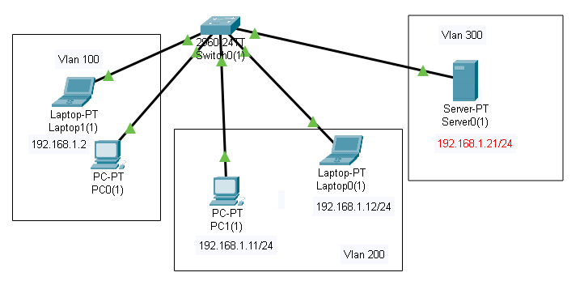
Fig: 4.1

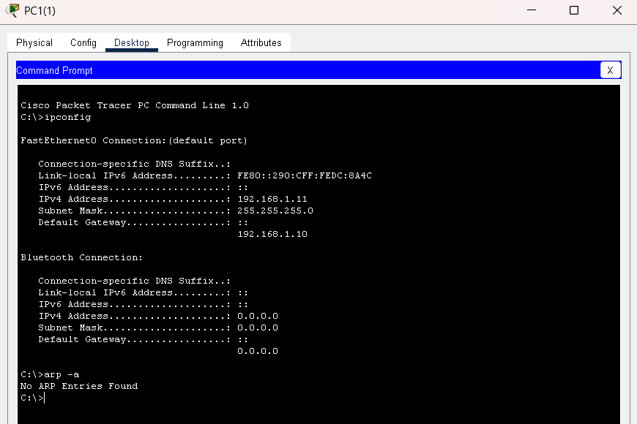
Fig:4.2

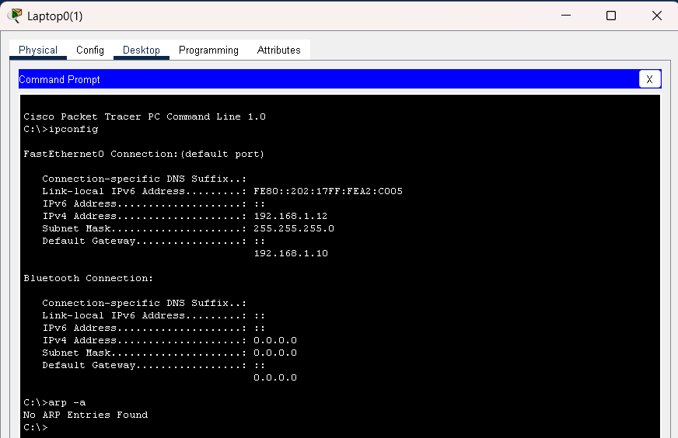
Fig:4.3
- In the Fig 4.2 and Fig:4.3 we can see the ARP cache and the ip address of both the end devices in a vlan
- We can’t communicate with other vlans untill we have a inter vlan configuration using a Multikayer switch or Router.

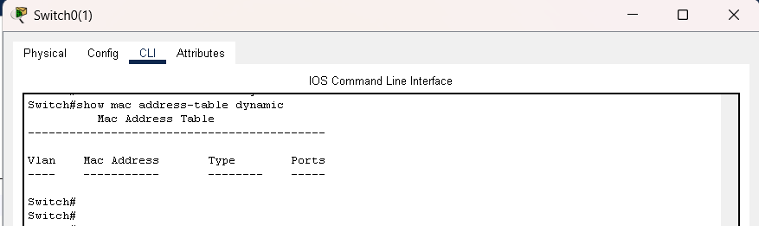
Fig:4.4
- This is the Figure of as we saw the ARP cache is empty this switch mac addres table is also empty
- And we can see this using the command “show mac address-table dynamic”

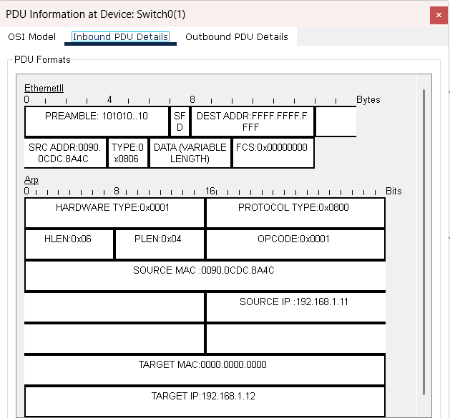
Fig:4.5

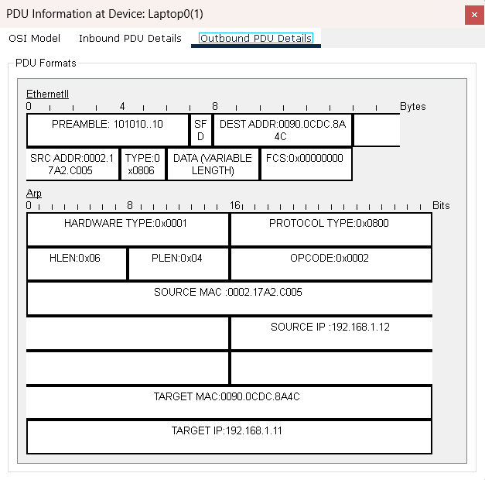
Fig:4.6
- The source device with IP 192.168.1.11 sends an ARP request to the switch. The switch broadcasts this ARP request, and the target device with IP 192.168.1.12 receives it and replies with its MAC address.
- In the ARP response, the target IP shown is 192.168.1.11 (the initiator), while the sender is 192.168.1.12.
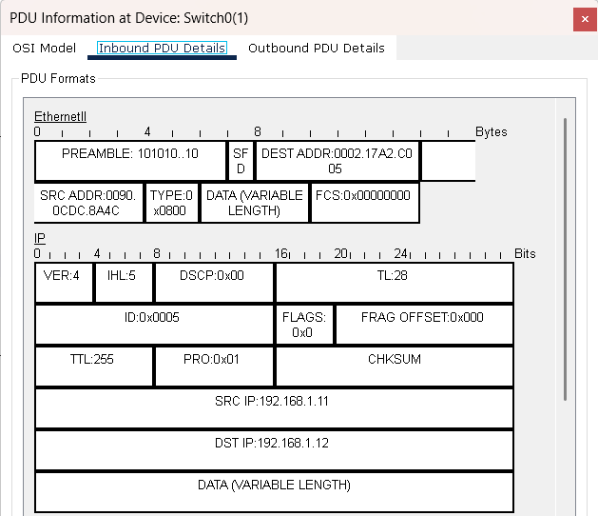
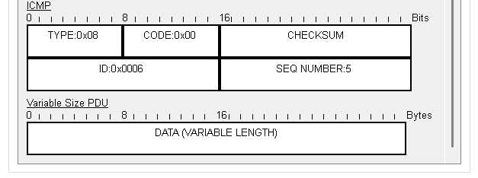
Fig:4.7
- After learning the MAC address, the source device 192.168.1.11 sends an ICMP packet (ping request) to the destination 192.168.1.12, where the ICMP type is 0x08 (Echo Request) and the code is 0x00.

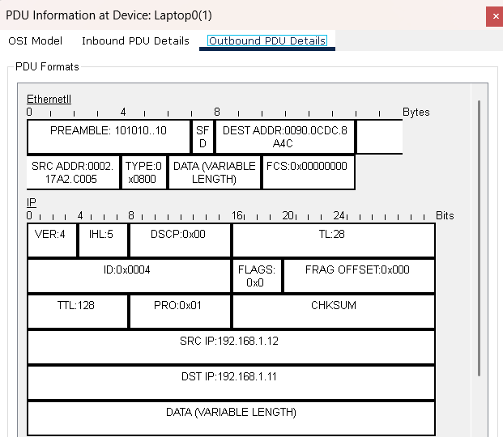
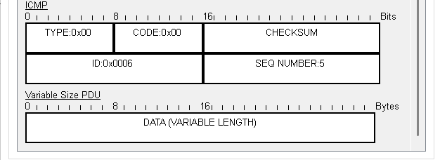
Fig:4.8
- The target device 192.168.1.12 replies with an ICMP response to 192.168.1.11. Since there are no Layer 3 devices or hops in between, the TTL remains the same, and this confirms successful communication between the two devices inside VLAN 200.
- In Fig: 4.9 we can see the packet after successful echo resoponse.

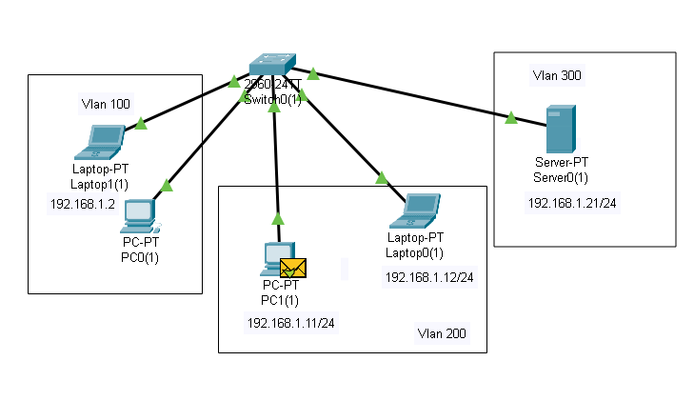
Fig:4.9

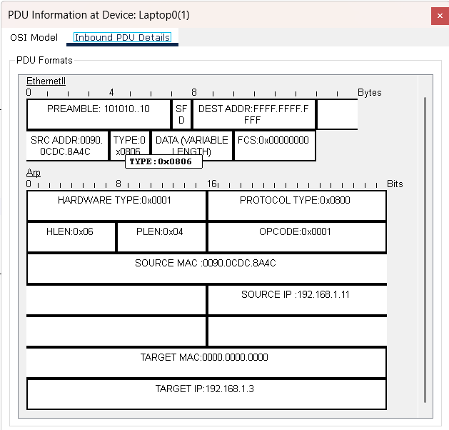
Fig:4.10

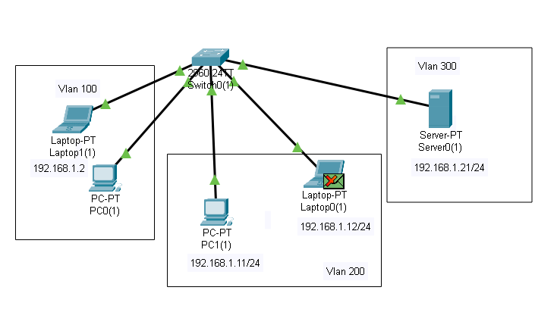
Fig:4.11

- Next, when trying to ping 192.168.1.3, which belongs to VLAN 100, the switch does not have the MAC address for this IP in its ARP cache. The switch broadcasts the ARP request only within VLAN 200 and not to other VLANs
- So the device in VLAN 100 does not receive the request. As a result, communication between these two VLANs fails. To enable successful communication between different VLANs, Inter-VLAN routing is required, which will be set up in the next topology.

Network Topology : 5
- This topology is designed with inter-VLAN configuration. For this setup, three VLANs are created: VLAN 100, VLAN 200, and VLAN 300.
- These VLANs are interconnected, and intercommunication is configured with the help of a multilayer switch, as shown in Figure 5.1

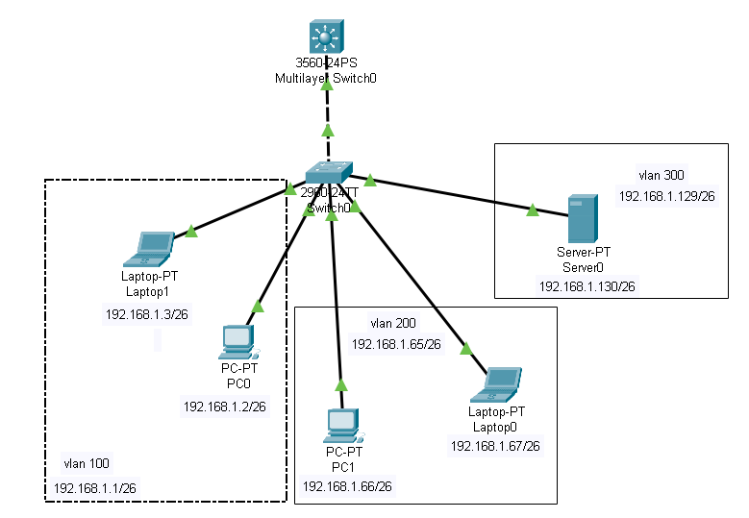
Fig: 5.1
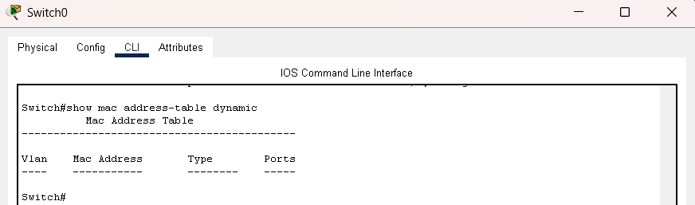
Fig: 5.2
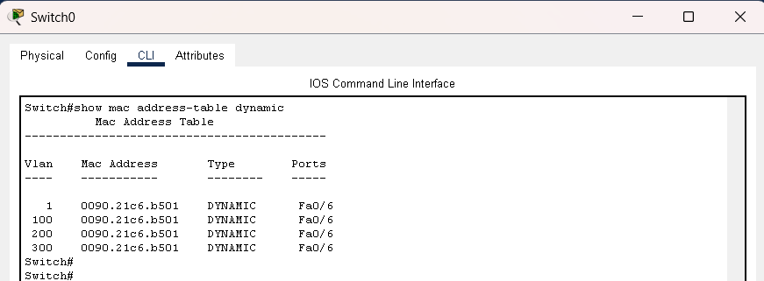
Fig: 5.3
- Figures 5.2 and 5.3 display the MAC tables of the switch before and after the ARP broadcast.

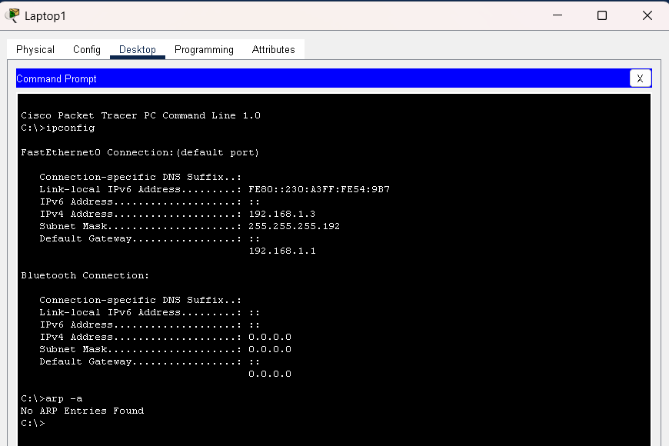
Fig: 5.4

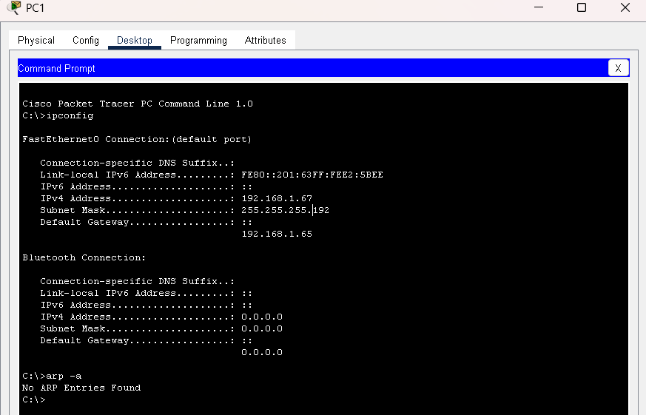
Fig:5.5

- Before the ARP broadcast, the ARP cache in both the source and destination devices is empty.
- The source device has the IP address 192.168.1.3 and the destination device has the IP address 192.168.1.66. As shown in Figure 5.4 and Fig 5.5.
- These two devices are in different VLANs, where the source belongs to VLAN 100 and the destination to VLAN 200.
- When the ARP request is initiated from the source device 192.168.1.3, the switch broadcasts it, and it is forwarded to the default gateway 192.168.1.1.
- The multilayer switch then sends the ARP response back to the source device 192.168.1.3, where the source IP in the reply becomes the default gateway of the device, i.e., 192.168.1.1.
- We can see this process in Fig 5.6, Fig: 5.7 and Fig: 5.8.
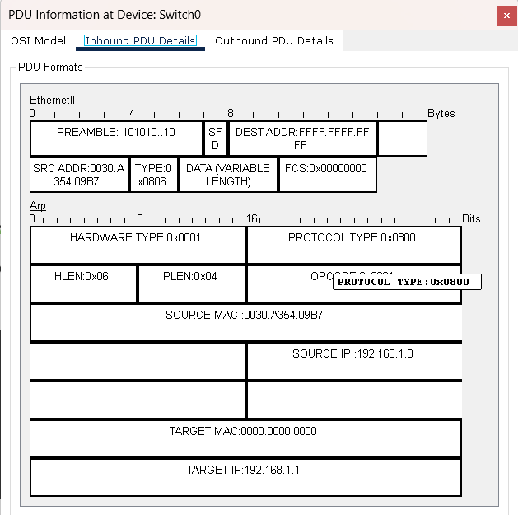
Fig; 5.6
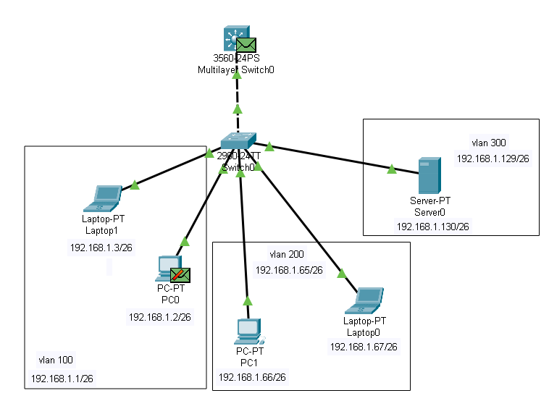
Fig: 5.7
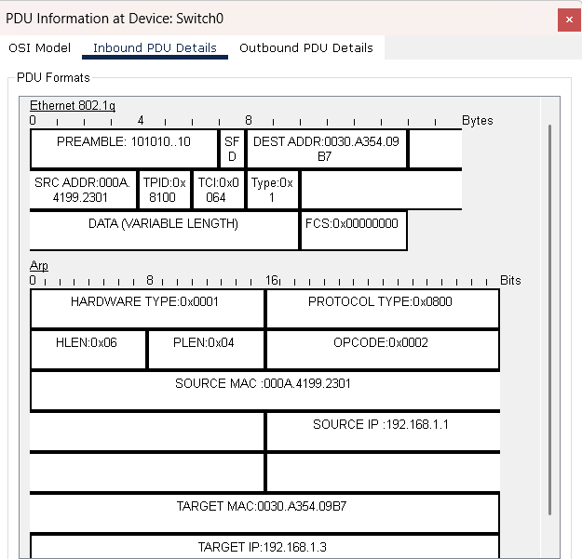
Fig: 5.8

- After this ARP exchange, an ICMP packet is sent from 192.168.1.3 to the destination 192.168.1.66.
- The ICMP type is 0x08 and the code is 0x00. Initially, the packet is dropped at the multilayer switch because it does not know the MAC address of the destination IP 192.168.1.66.
- At this point, the multilayer switch generates a new ARP request for the destination address. In this ARP request, the source IP is 192.168.1.65, since this is the default gateway for 192.168.1.66 as configured in the multilayer switch.
- The request is then broadcast within VLAN 200. The packet is dropped at 192.168.1.67 because it is not the intended target; instead, the search is for 192.168.1.66.
- In 5.9 and 5,10 we can see the packet initiation and drop at default gateway.

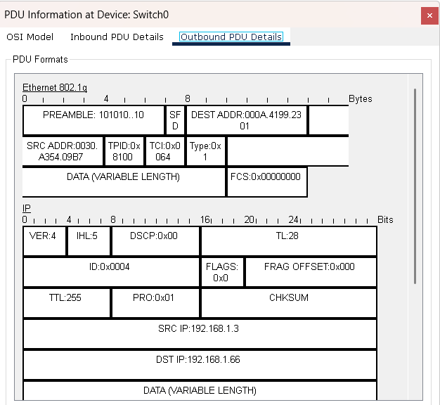
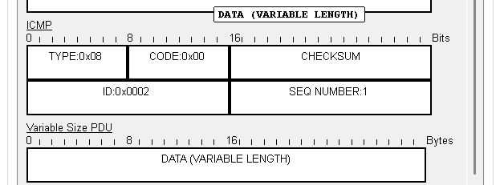
Fig: 5.9

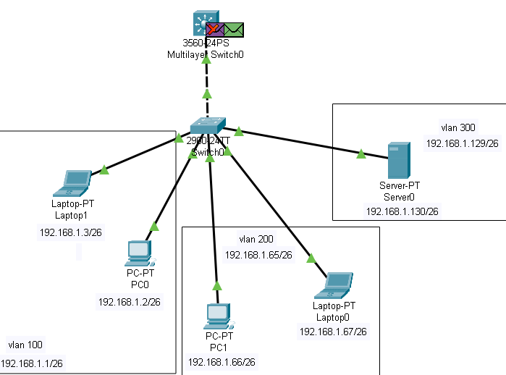
Fig: 5.10
- In this ARP request, the source IP is 192.168.1.65, since this is the default gateway for 192.168.1.66 as configured in the multilayer switch.
- The request is then broadcast within VLAN 200. The packet is dropped at 192.168.1.67 because it is not the intended target; instead, the search is for 192.168.1.66.
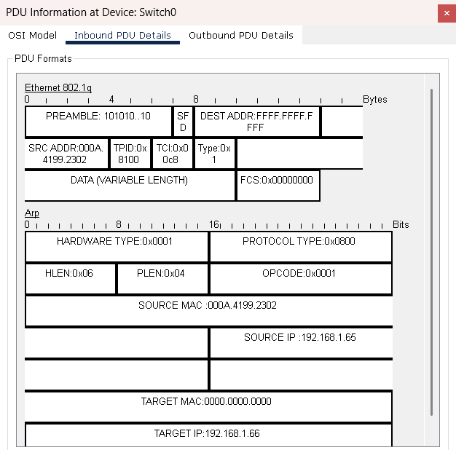
Fig: 5.11

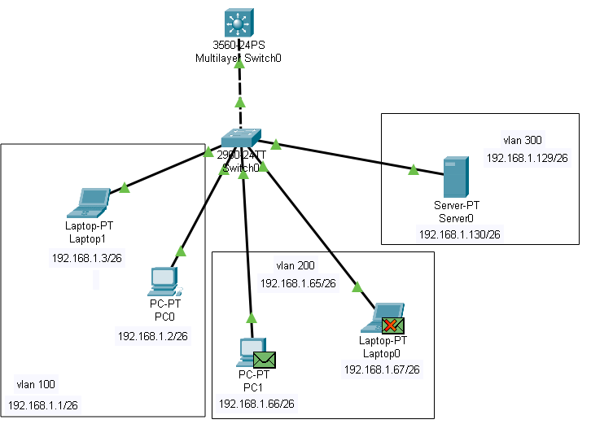
Fig: 5.12
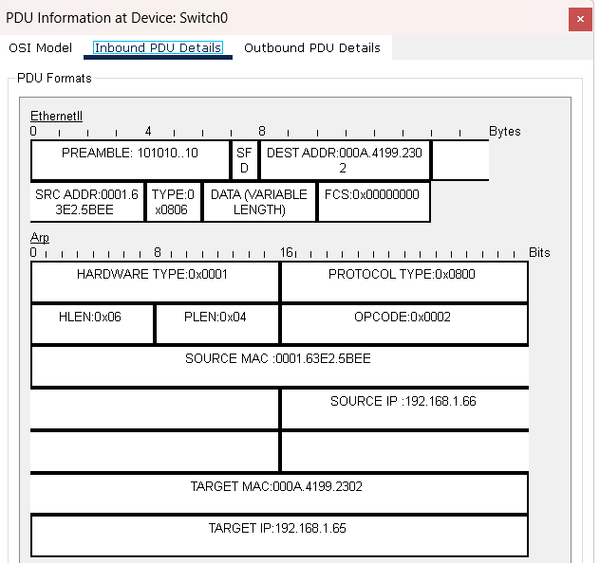
Fig: 5.13 – ARP response
- Once the correct device 192.168.1.66 is found, it replies with an ARP response to the default gateway.
- This ARP response has the source IP 192.168.1.66 and is directed toward the gateway at 192.168.1.65.
- After receiving this reply, the ICMP packet flow resumes successfully from the source device 192.168.1.3 in VLAN 100 to the destination device 192.168.1.66 in VLAN 200.
- The destination then sends back an ICMP echo reply to the source with type 0x00, confirming successful inter-VLAN communication.
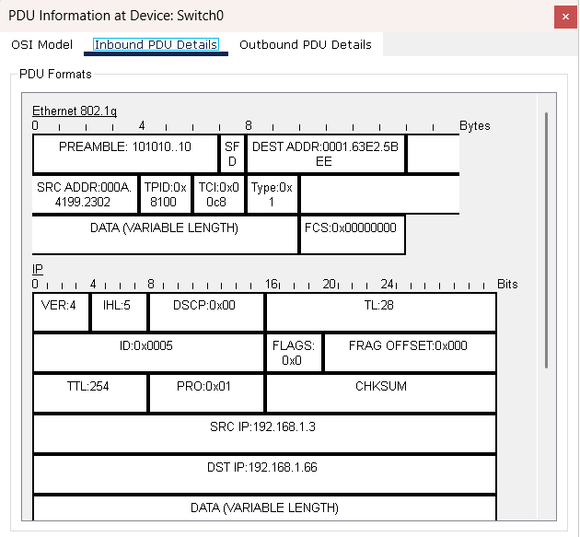
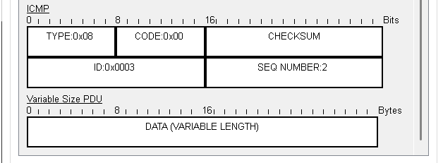
Fig: 5.14 – Echo Request

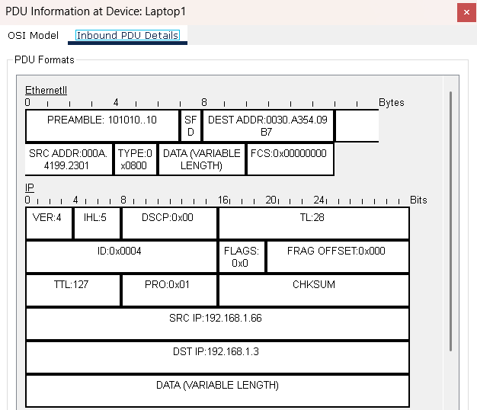
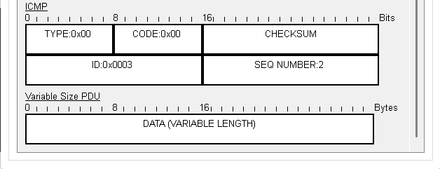
Fig: 5.14 – Echo Response

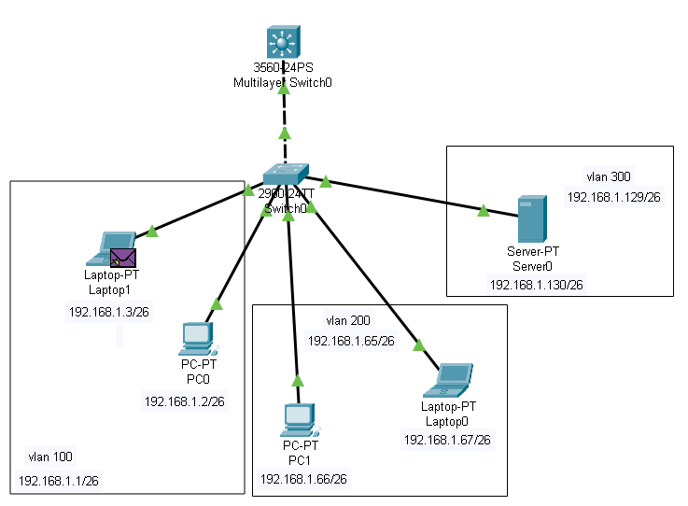

- This successful packet flow is achieved through inter-VLAN configuration, also called Switch Virtual Interface (SVI) configuration, on the multilayer switch.
- To configure this, the required VLANs are created on the switch: VLAN 100, VLAN 200, and VLAN 300. Each VLAN is assigned a subnet. For this setup, a /26 subnet is used, providing four subnets, and three of them are allocated to the VLANs.
- After creating VLANs on the switch, the interfaces are tagged according to their VLAN and subnet. In this topology, VLAN 100 has two devices, VLAN 200 has two devices, and VLAN 300 has one device.
- The port connecting to the multilayer switch is configured as a trunk port so it can carry traffic for multiple VLANs, and the corresponding port on the multilayer switch is also configured as trunk.

- On the multilayer switch, IP routing is enabled. Then, SVI interfaces for each VLAN are created with their IP addresses:
  - VLAN 100 → IP 192.168.1.1, Subnet mask 255.255.255.192
vlan 100
interface vlan 100
ip address 192.168.1.1 255.255.255.192
no shutdown
  - VLAN 200 → IP 192.168.1.65, Subnet mask 255.255.255.192
vlan 200
interface vlan 200
ip address 192.168.1.65 255.255.255.192
no shutdown
  - VLAN 300 → IP 192.168.1.129, Subnet mask 255.255.255.192
vlan 300
interface vlan 300
ip address 192.168.1.129 255.255.255.192
no shutdown
- For each interface VLAN, the commands include assigning the IP address, applying the subnet mask, and using the no shutdown command to activate the interface.
- Once these VLANs and SVIs are configured, inter-VLAN communication between VLAN 100, VLAN 200, and VLAN 300 is established successfully.

Network topology 6:

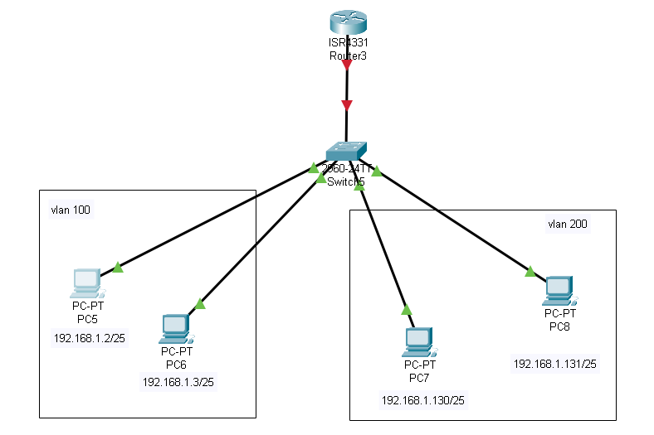
- This is a topology which is designed for inter vlan routing between 2 different vlans using Router
- Created 2 vlans vlan 100 and vlan 200
- We have 2 hosts in both the vlans

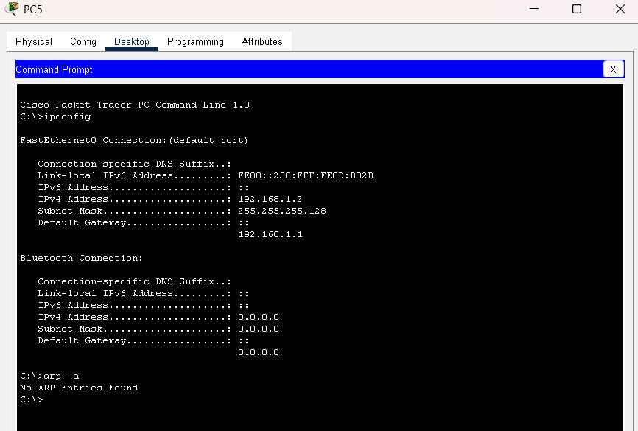
- The above image represents the ip address in vlan 1 and it’s subnet mask is 255.255.255.128
- The host in vlan 200 have different address and it is in different subnet
- Now to enable the communication between these 2 vlan using Router
- This method is called as router on a switch
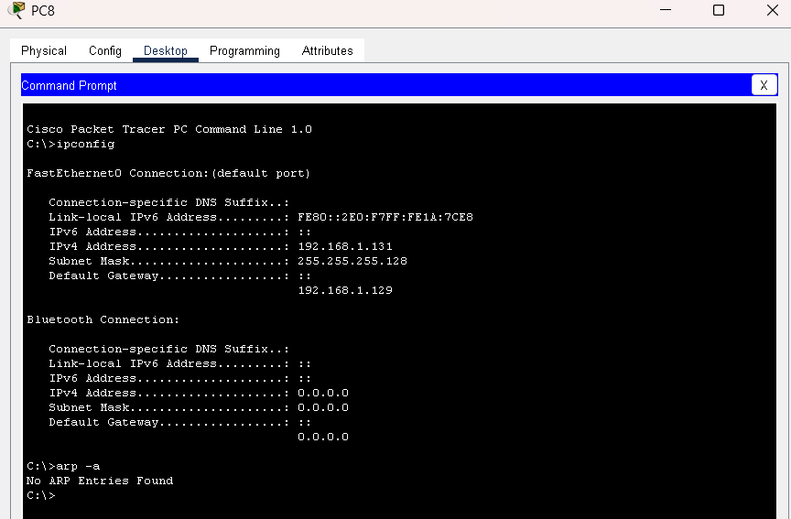

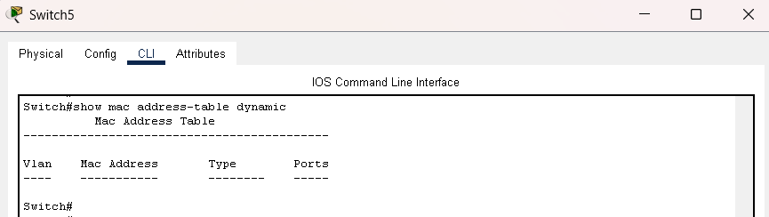

- The mac address table in the switch is empty because there was no commmunication happened between devices
- If any host try to communicate with a destination host then the switch will update it’s mac table with source mac address
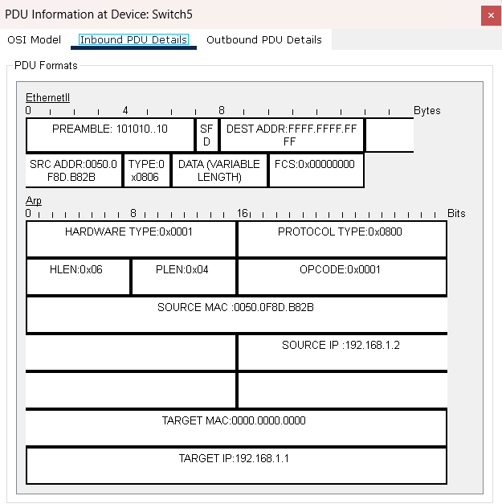
- Here The ARP request is generated by host in vlan 100 that is 192.168.1.2 to communicate with the 192.168.1.131
- But here the target ip is 192.168.1.1 because the host it Is looking for is in different subnet so the router will provide it’s hardware address on behalg of 192.168.1.131
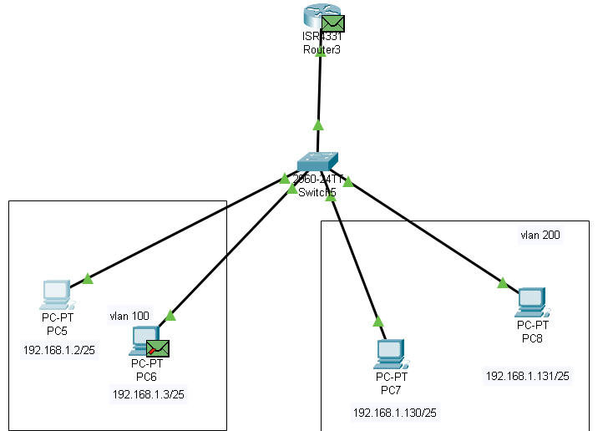
The above image is the ARP request that is sent by the host in vlan 1 that is 192.168.1.2
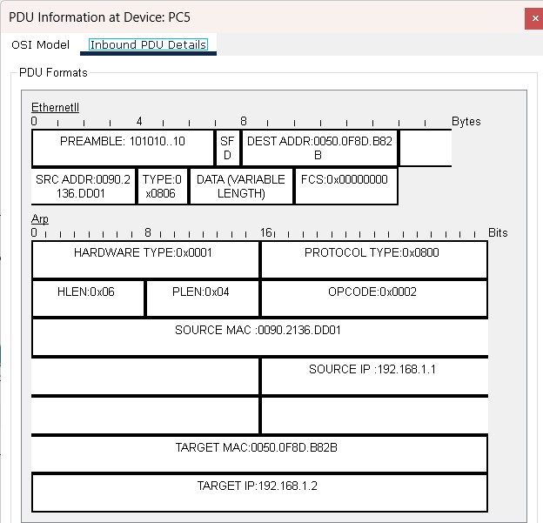
- The response from router is that it will provide it’s hardware adress and then it will forward that packet to the destination.

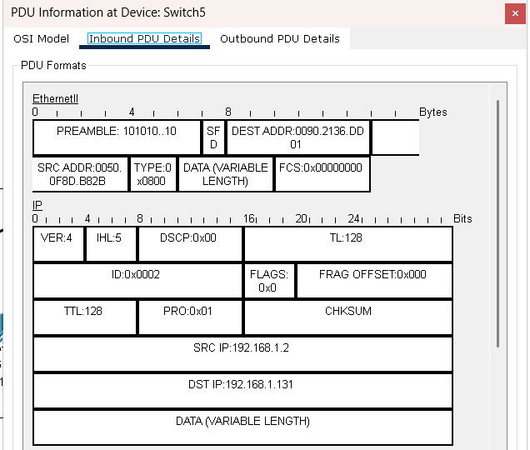
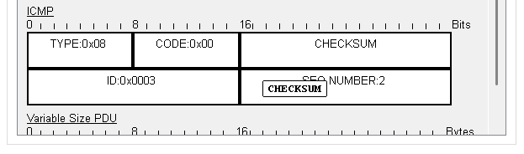

- The above image is the icmp packet format that is been sent by the host 192.168.1.2 and the destination is 192.168.1.131
- Now this packet will be sent to 192.168.1.1 and then the router will forward this packet to destination host.

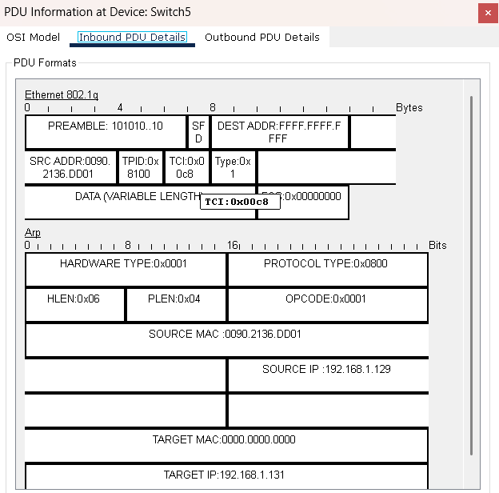
- Now the router will again send a ARP request to know the target ip mac address and it will sent to the vlan 200 subnet
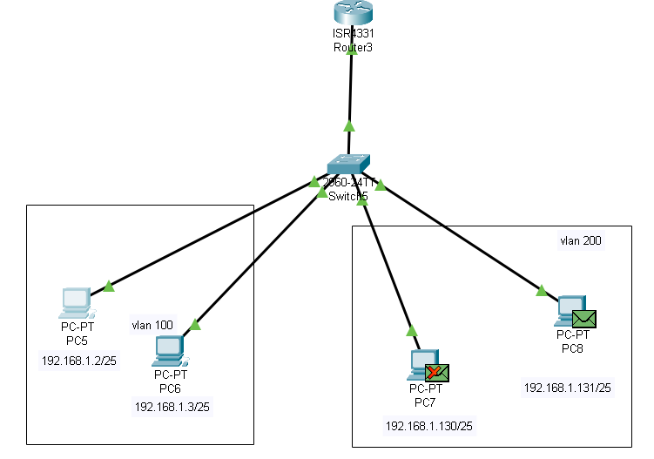
- Here the intended target host will replay with it’s mac addres and other devices will drop that frame.

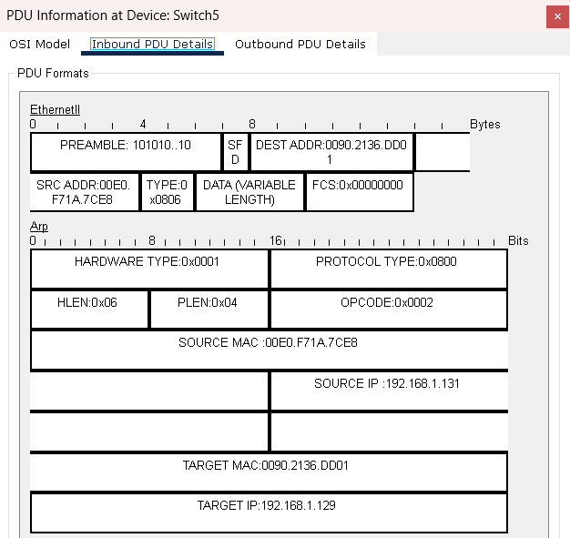
- This is the ARP response from the target ip and after this response the router will communicate with the target ip.

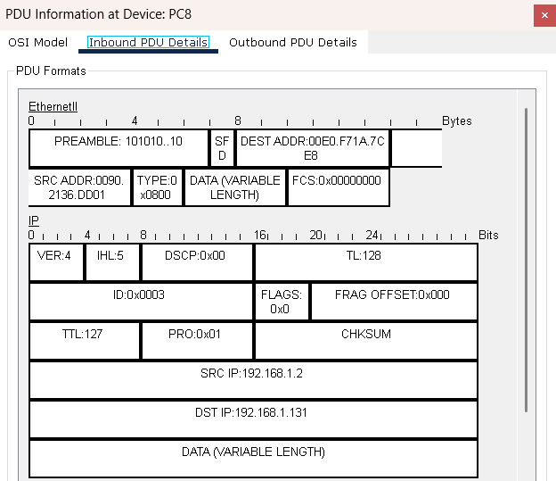
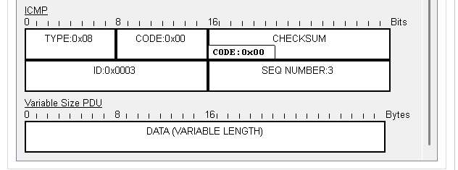
- This is the ICMP packet that is sent by the host and the target ip is 192.168.1.131

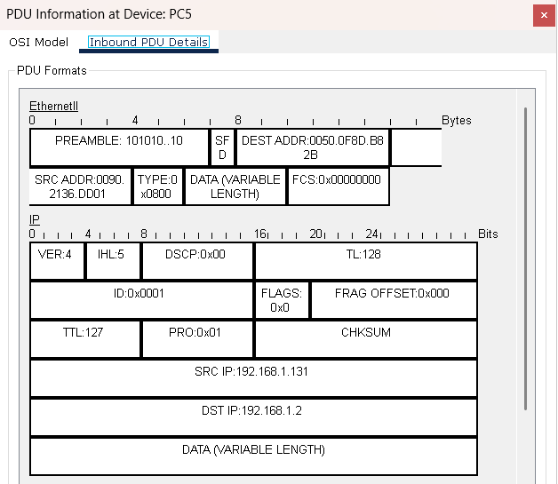
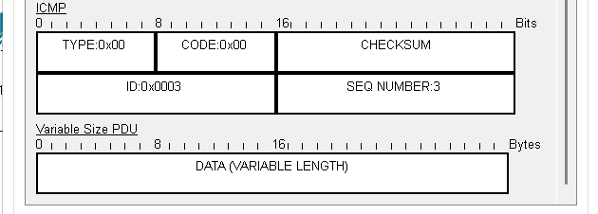
- The response from the target ip to the source host 192.168.1.2. But we can see here the source is 192.168.1.131 because it is responding now so it will be the source.
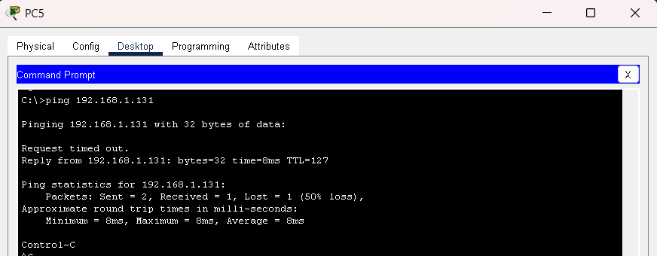
- Here we can see that at first we see request timed out and then we got a echo reply because at the router the packet will be dropped first because it don’t knoe the mac address of target ip.
- So after the resolution of mac the echo reply was successful
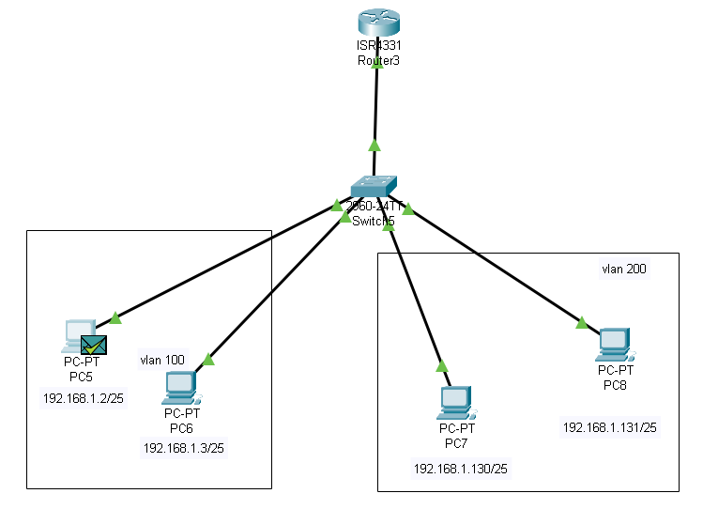
- This is the successful inter vla routing on router. And we can see that the icmp response was succeessfully received by the source host.

Topology 7:
This is a topology that how dhcp client will receive the ip address from dhcp server.
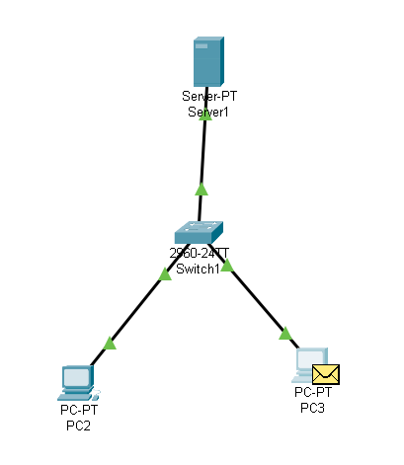
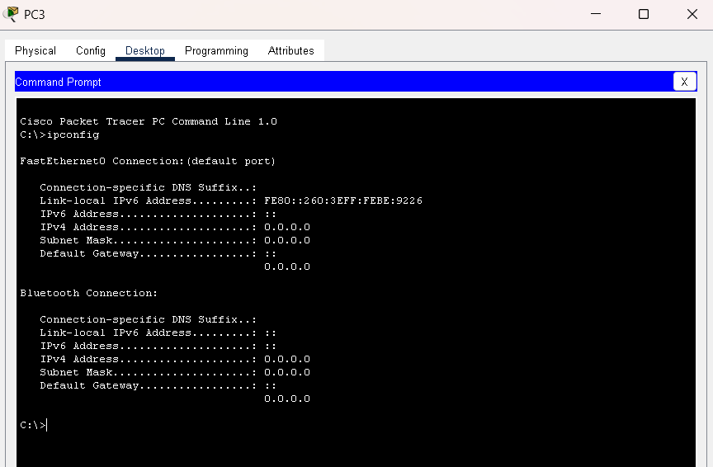
Here we can see that at first the host is not having any ip and it is sending an DHCP discovery message to the network

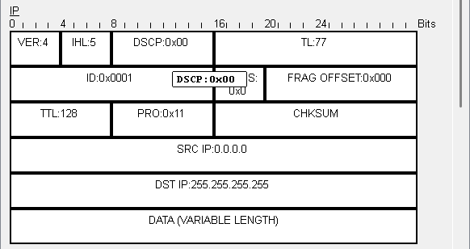
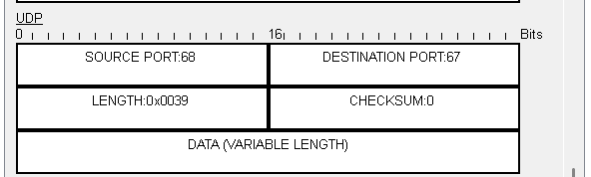
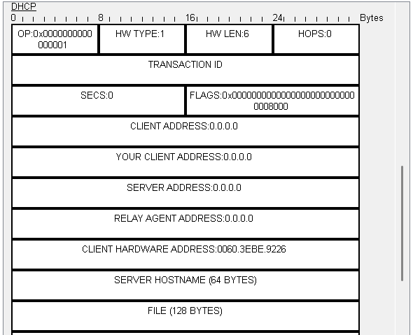
Here we can see that the source ip is 0.0.0.0 and the destination is 255.255.255.255 because initially it don’t have any ip so it is doing broadcast.
That source port is 68 which Is DHCP client and 68 is for DHCP server
In DHCP header we can see client address and server address as 0.0.0.0 because it’s discovery message so it don’t know any server.

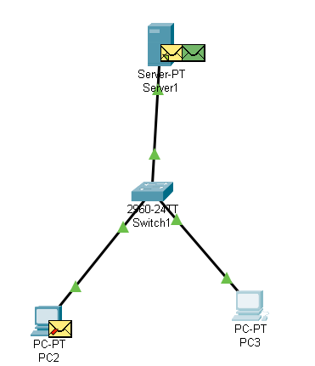
Here we can see that broadcast message by PC3 to discover the server.

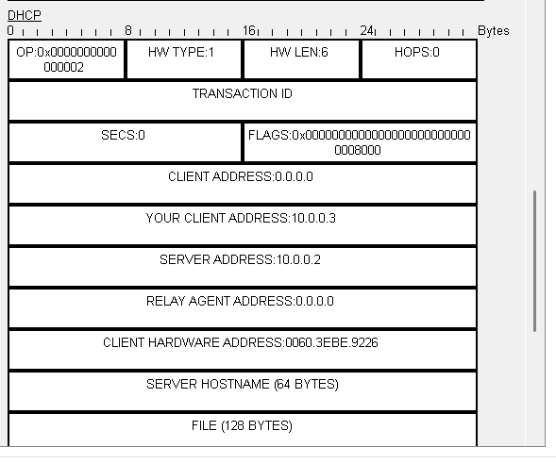
This is the response from server and it’s sending 10.0.0.3 for the client
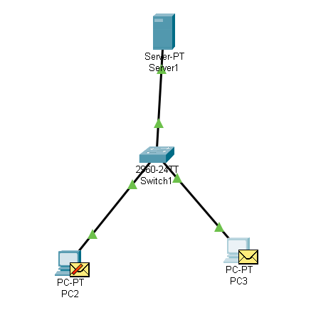
And server will also do broadcast because client still don’t have the ip so it will do broadcast and here we can see the source is DHCP server that is port 67 and the client is 68

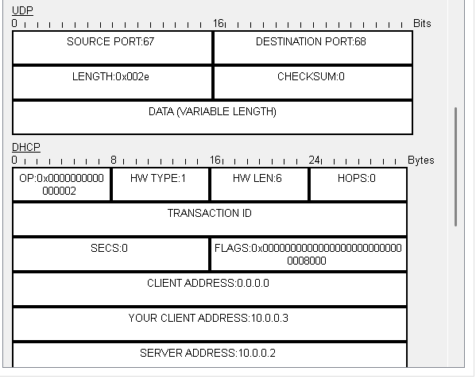

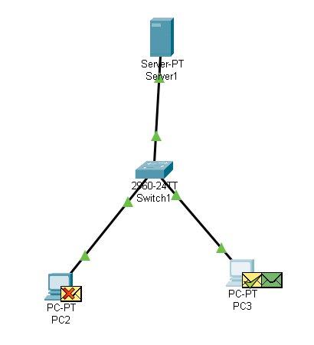
Here we see that the client has accepted the ip address and before this the client will do a DHCP offer message and then receives a acknowledgement message then client will assign that ip address.
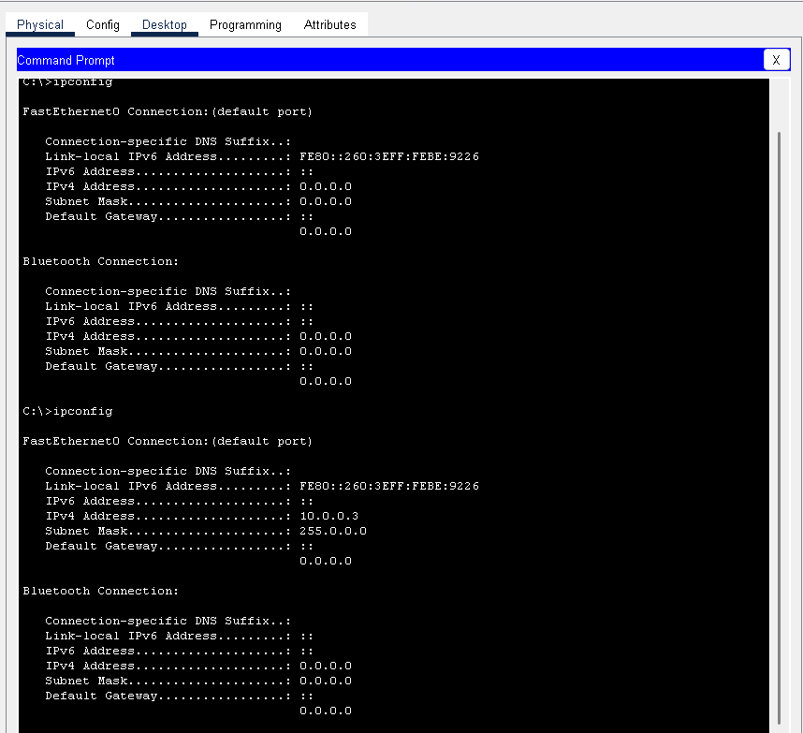
We can see that the ip address of the host after this DHCP process and it assighned that ip address 10.0.0.3.

